***We proudly present the new devon example application: MyThaiStar – the new digital restaurant***

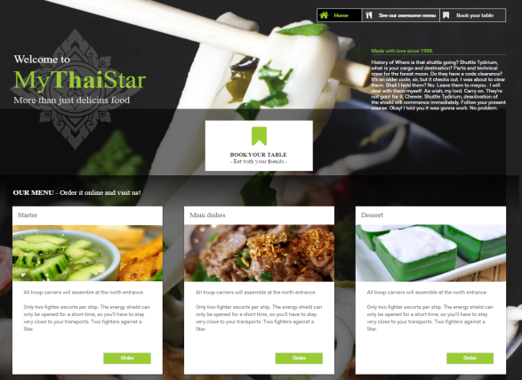

The team (member1, member2, ...) and the product owner “member x” has relaunched the new example app for devon! It is out now and can be access by everyone by following this link: <link>

The new example still sticks to the domain of restaurants but now the customer who visit the restaurant is the main actor.

______________

The User Interface of the new example application is more appealing and offers **three new, fancy and simple features**:

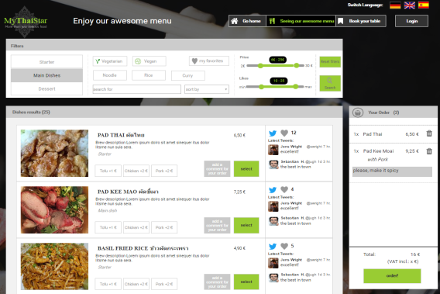  
  
Digital Menu: Order you dish before visiting the restaurant and reduce you waiting time. Use a filter to find your favorite dish, decide which meat you’ll like and order it easy before your visit.

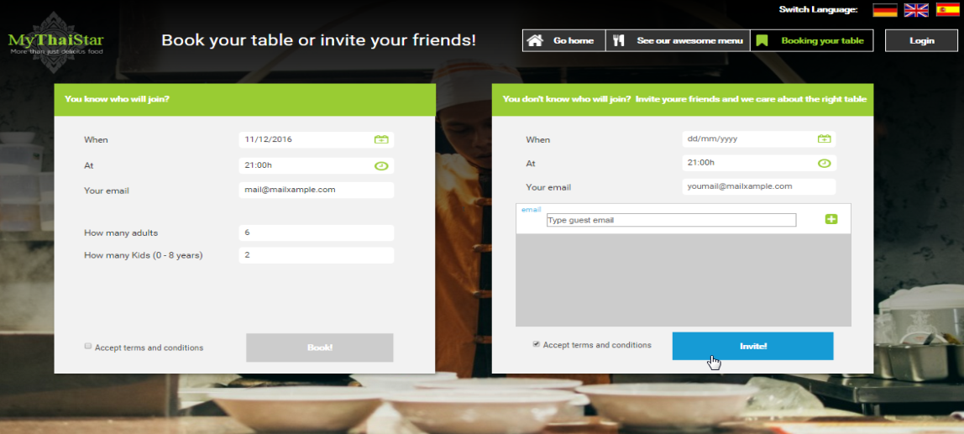Invite your friends: you do not know how many guest you expect? Then use the new Invite your friend feature. Just enter your friends email address of potential guests. Everyone receives an invite and according to their answer the system will book the table automatically – with the right number of guests!

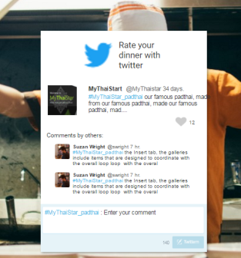  
Rate your menu by twitter: Give us feedback after you have visited us. By integrating twitter in our rating system you only need a twitter account to give us feedback or to add you favorite dishes to your favorite list. Further you can read other comments from other guest to find some new, delicious food for your visit.

All new features are **easy to understand**, follow the **KISS-principle** and are **independent from any business domain** (everyone understand it as everyone has visited a restaurant before ☺).

The new user interface follows the concept of a **SPA** (single page application), is build on [**Sencha | AngularJS**] and is **responsive for mobile usage**. The example shows how easy it is to **integrate twitter** with devon, how to set up **easy CRUD operations** (e.g. for maintaining dishes) or how to **apply I18N**. The only roles in this application are the customer and the chief of the restaurant. The previous roles like cook or waiter are omitted in order to reduce complexity in the new example application.

By diving into the code of this example **you’ll learn how to apply devon** for your projects and you’ll gain knowledge about several **best practices** how to do it. Here you go <link>.

What’s next: In our future release we will add more features like a **dashbaord/portal retrieving data from multiple microservices**. This dashboard shall be used by the restaurant chief for viewing all orders, twitter comments, daily reports.... Another feature is to enable **social login** by using facebook or google credentials.